 THORGUARDIAN L125 / OPERATIONAL LIGHT
INSTALLATION PROCEDURE – TSB 032805
Tools Required
Adjustable Wrench, Power Drill, Electrical Tape,1/2 drill bit,5/32 drill bit, #1 & # 2 Phillips Screw Driver

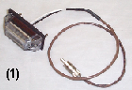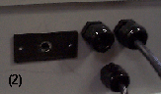Installing Light
(1) You have been supplied an LED (+12V DC) with a cable attached. The rated life of the LED exceeds 100,000 hours. All new factory systems
will have the light secured directly to the bottom of the enclosure.
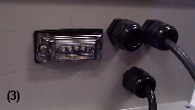
(2) Remove the gasket from the light. Place the gasket against
the box, mark the location for each hole. Ensure the holes will
not interfere with the interior battery or the bracket.

(3 ) Drill each hole, and mount the light using enclosed hardware.

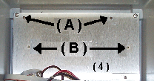Installing L125

Turn off AC power, disconnect all wires attached to the battery,
and either remove battery or place black tape over Red terminal.
Disconnect “White” timer control cable attached to Relay board.
Loosen mtg. hardware & remove Timer from THORGUARDIAN.
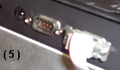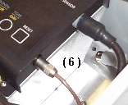
Remove L25 power cable & Sensor cable. Loosen existing L25 chassis mounting plate screws & remove L25. Remove Gray ribbon cable. Save all hardware.

Remove Existing Relay Bracket and install new “L125” Relay bracket Reconnect all cables.
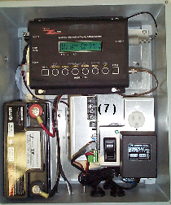
- Transfer existing mounting screws from ( A ) to ( B ). Allow
for a 1 /4 gap do not tighten screws.

(5) Attach gray Ribbon cable to connector on the L125 label
“RELAY”. Secure with existing hardware. Attach power cable.

(6) Examine the Sensor cable connector and install in the L125 using the correct orientation. Route the LED cable between the Relay bracket and the battery and connect to the right side of the L125.

(7) Secure L125 , which is currently attached to the mounting
adapter, to the main plate. Check that no wires have been pinched.
Ensure all L125 mounting screws are tight.

(8) Connect Black wire to the lower Negative Battery Black terminal
Connect Red wire to the top Positive Battery Red terminal.

(9)Turn on AC power. This completes installation. Proceed to “L125 SETUP”

1193 Sawgrass Corporate Parkway Sunrise, Florida 33323 Tel (954) 835- 0900 Fax (954) 835 - 0808

